Improving rice competitive to weeds by frequencies of weeding in Japanese organic farming

Margi Asih Maimunah^{1,2}, Valensi Kautsar^{1,3}, Samuel M. Kimani¹, Nanami Sekishita⁴, Yuka Hosogoe⁴, Shinkichi Takami⁴, Keitaro Tawaraya⁴, Hideki Murayama⁴ and Weiguo Cheng⁴

¹The United Graduate School of Agricultural Sciences, Iwate University, Morioka, Japan
²Faculty of Agriculture, Universitas Gadjah Mada, Yogyakarta, Indonesia
³Faculty of Agriculture, Institute of Agriculture Stiper, Yogyakarta, Indonesia
⁴Faculty of Agriculture, Yamagata University, Tsuruoka, Japan

Mechanical weeding is one common weeding practice that have been applied by Japan organic farmer. Optimizing weeding practices is one significant key to support organic rice growth and reach higher yield. Therefore, the study aimed to evaluate the competition between rice and weeds under different frequencies of mechanical weeding. A three years-field experiment was conducted in one organic rice plot located in Yamagata University Farm, Tsuruoka, Japan. The transplanting of Rice (cv.Sasanishiki) was done in end of May and harvested in September 2019, 2020, and 2021. The treatment was different weeding frequencies (0, 2, 4, 6, and 8 weeding frequencies (WF)) from 0 to 56 DAT (days after transplanting). Rice and weeds were sampled at harvest time. Meanwhile the plant growth was investigated at rice panicle initiation, flowering, and ripening stage (harvest time) in each year. Our findings showed that 8 times of weeding reach highest total rice biomass at harvest time (1298.85 g.m⁻², 1032.81 g.m⁻², and 1145.73 g.m⁻² in 2019, 2020 and 2021, respectively). The more weeding frequencies resulted in higher N concentration in both rice and weeds. However, rice N uptake increased whereas weed N uptake decreased. Total N uptake for both rice and weeds in 8WF was highest in 2021, with rice accounting for 90% (9.21 g N m⁻²), 96% (6.85 g N m⁻²) and 86% (7.17 g N m⁻²) of total N uptake for both rice and weeds in 2019, 2020 and 2021, respectively. The most dominant weeds found were Echinochloa crus-galli (Hie), Monochoria vaginalis (Burm. f.) (Konagi), Schoenoplectus juncoide (Inoho) and Eleocharis kuroguwai ohwi (Kuroguwai). Hie dominated the field in 2019 before declining in subsequent years. Kuroguwai appeared swiftly in 2020 and rapidly grew its population in 2021, becoming the most dominant weed. However, each weeds response negatively to the frequencies of weeding in the density and N uptake. Among the weeds, konagi had the highest N intake among weeds, as well as a steady population over three years and was suspected of being the weed that most affected rice N uptake. These findings indicate that the 8WF treatment enhanced rice growth and strengthened its competitiveness to weeds, while weed development was severely hampered as 8WF was applied.

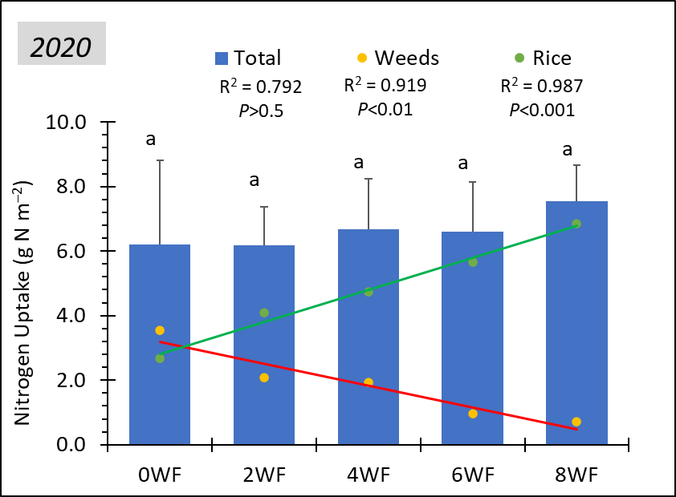
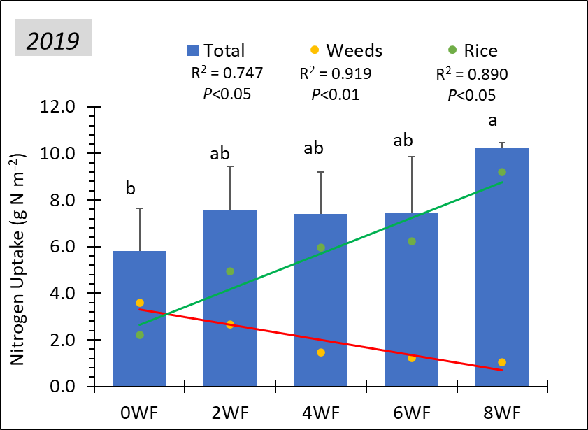
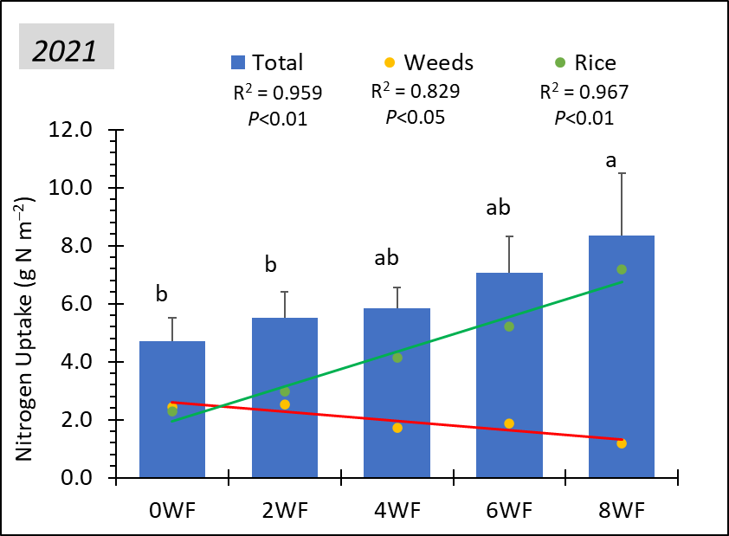

Fig. 1. Correlation between weeding frequencies and total nitrogen uptake (g N m⁻²) of rice and weed or each nitrogen uptake of rice and weed in 2019, 2020, and 2021.

Key words: Nutrient competition, weeds density, mechanical weeding

Co-responding author: Margi Asih Maimunah
Position: Ph.D student
Affiliations: The United Graduate School of Agricultural Sciences, Iwate University (in Faculty of Agriculture, Yamagata University)
Country: Japan
E-mail : margi.asih.m@mail.ugm.ac.id

